UpDo 2018 – Fundraising Drive - April 8 to May 6, 2018 | 925 Blairs Ferry Road Marion, IA 52302  319.447.1688  cornerstone-marion.org

Objective
UpDo 2018 ("Up, Down, Out") is a 4 week financial raising endeavor designed to raise funds for three concrete goals:

Goals

We want to Update our facility. | The next 3 phases include finishing the ceilings in the Nursery and Children's Church (in progress, projected cost $21,000), moving next to a facelift, new rooms, and remodel in our front foyer area (see drawings next page), and then, Lord willing, updating the outside of our facility's front facade. We will not take any debt to accomplish these projects. Would you help us “do up” our facility?

We want to pay Down our mortgage. | It is time to refinance our 5-year adjustable mortgage (sadly with a bit higher rate than we had in 2013). This is a perfect time to be good stewards by lowering our current $315,000 of debt (about half of the building’s worth). Every penny can lower our outstanding debt load.
We want to send money Out the door. | Cornerstone is committed to advancing the gospel locally and globally. As such, we want to give a double-tithe (20%) of all UpDo giving to local and global works for Christ.

Mark YOur calendar

Time span | April 8 - May 6
We'll announce final giving numbers during our Family Meal and Congregational Meeting on May 6.

Not this kind of Updo
Financial Breakdown:
60% of all gifts will go to our Building Fund for future Updates.
20% of all gifts will be earmarked for paying Down our current mortgage.
20% of all gifts will go Out to local and global gospel initiatives:
1/4 will go to the Harvest City Church Plant in Iowa City
1/4 will go to the Church Planting fund for the Central District of the Evangelical Free Church.
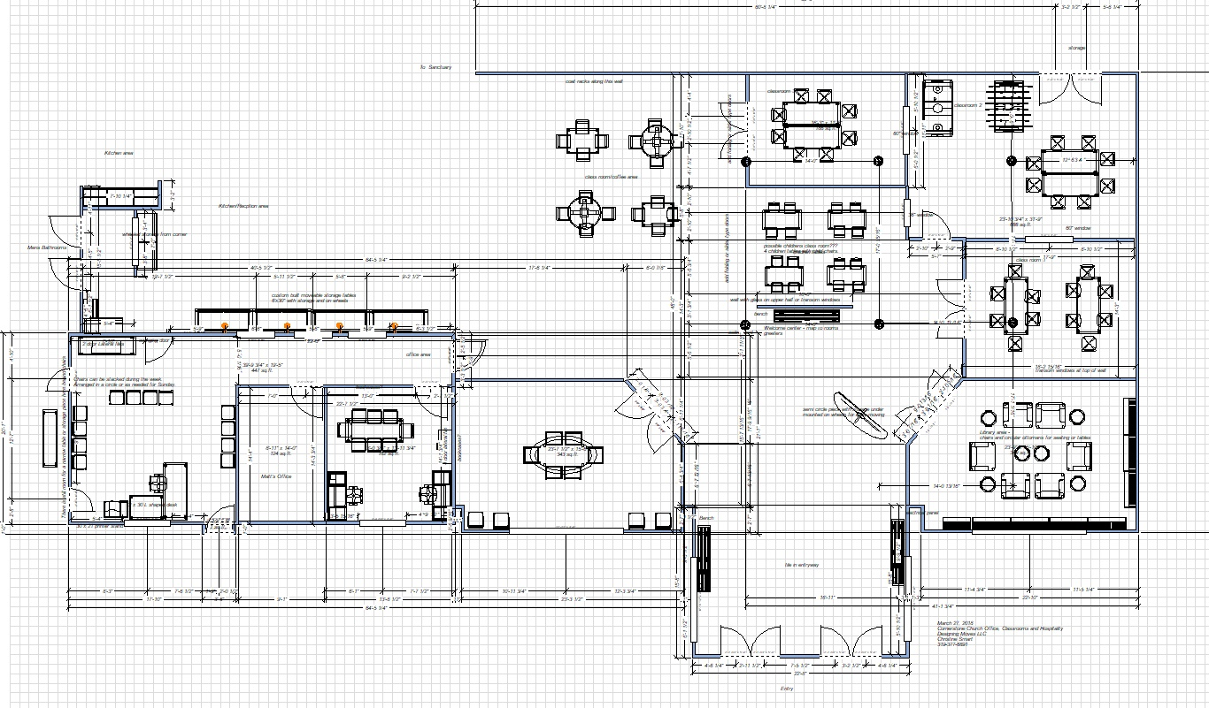
The remaining half will be divided evenly for our current missionaries (Couches, Hesses, Colliers, McKinnons).
More Classrooms
Main Entrance
New Classroom

Please memo your checks as “UpDo 2018” when putting them in the offering box or attach a note if giving cash. Similarly, if you give online (http://cornerstone-marion.org/2017/07/20/give-online/) please be sure to indicate if your gifts are going toward this financial raising endeavor.

If you have any questions, please reach out to the elders (Doug Hammes, Randy Pospisil, Matt Proctor, & Alex Steele) or deacons (Greg Dryden, Darrel Herschberger, & Rob and Jennifer Taylor). Together, we made the joint decision to begin this fundraising drive.
Dear Cornerstone Family,

With this letter you are receiving a letter from Pastor Matt about his upcoming sabbatical. I hope you’ll take a few moments to read it over and pray for him over the 8 weeks that he and Carrie will be renewed and refreshed.
The elders wanted to to remind you why we as a church body have this built into our plan for pastors. The sabbatical policy was put in place by the Congregation in May 2013 as a plan for all pastoral staff. We believe in this policy because it’s good for the health and well-being of our pastor and the health of our church.
First, it’s good for our pastor. Pastoral ministry is unlike just about any other job. As a former pastor, Randy knows this first hand. Pastors are always working. Every conversation you have with a friend is a potential counseling session, every book you read is preparation for a sermon or a lesson, every decision you make is scrutinized by a watching public. Whether we mean to or not, churches put a lot of pressure on pastors. Matt will be the first to point out that he knew this was part of the job, and that he feels called by God to fulfill this ministry, but that doesn’t make it any less stressful.
Jesus took time alone to refresh and reconnect with the Father. He was often found alone in prayer. If the Maker of the Universe needs a break from ministry every once in a while, certainly his under-shepherds need a break too. Pastor Matt already has some alone time that he takes regularly. He has a monthly prayer retreat, a couple of times a year he gets away with the family to Hidden Acres camp, and he gets away annually for prayer. The sabbatical is a more extensive time to break away from the daily details and sharpen his focus on the grand picture of God’s work in the world and at Cornerstone.
The sabbatical is not a “vacation” for our pastor. Yes, there will be some traveling and relaxation, but it is with a specific purpose to refresh him and his family to continue on in the ministry with a fresh sense of God’s direction and calling. Pastor Matt has been very diligent in planning for these 8 weeks to seek God’s face and come back to Cornerstone ready to continue this important journey together.
But this sabbatical is not just for Pastor Matt. It’s also good for us at Cornerstone. In the 8 weeks that Pastor Matt is away we will have the opportunity to stretch ourselves in ways we might not otherwise. God has given all believers as gifts to the church for building each other up and carrying out the ministry. Having Pastor Matt around is a blessing indeed, but we also can be used by God to comfort the hurting, bind up the sick, and speak truth and love to one another. When our full-time pastor is away for a time it allows us to fill the gap and perhaps find a new way to serve as well.
Our prayer for the 8 weeks Pastor Matt is away is that God will give Matt a fresh vision and direction, and that God will give each believer at Cornerstone a fresh vision for how we can use our God-given abilities to carry out the work of ministry well past the sabbatical. Will you join us in praying for Pastor Matt and his family? And will you also seek God on how you can be used by Him to further His kingdom. Perhaps God will show you a need in our body, and you’ll recognize that God has shaped you in just the right way to fill that need. Be prayerful about finding that out, and be ready to jump into that gap.
May God richly bless you as you are a blessing to others.
Elders: Doug, Alex and Randy

Dear Cornerstone Family,
I consider it one of the greatest pleasures of my life to serve this body. You are my friends, my family, and fellow partners in the Gospel.
This is why I look at my 8-week sabbatical, starting May 7 as both bitter and sweet. Bitter because I will not see most of you for many weeks. Bitter because I will be missing out on the exciting ministries of this church family. Bitter because I will be absent in some of your joys and sufferings. Still, I know it will be sweet as well. Sweet to lay down some pastoral burdens. Sweet to remember my primary identity is as a child of God. Sweet to focus on the lives of those in my home. Sweet to connect with the LORD with no sermon in the wings. Sweet for my people to know how dispensable I am and how indispensable the LORD is.
Thank you for this privilege…thank you for this opportunity. I do not take it lightly. I am writing for a few reasons today besides to express my gratitude. Here they are:
#1: First, know that I will be unavailable from May 7 through July 2. I will not be checking email at all. I will check my phone occasionally, but I am committed to only respond to texts and calls from our elders (Doug Hammes, Randy Pospisil, and Alex Steele). If you need to get information to me or have a serious concern, please call one of the elders if you desire to get a hold of me.
#2: Second, please try to talk to me in the next few weeks if you have any pressing personal or ministry concerns. My final week will be very full so if we could meet to talk, pray, or plan sooner is better than later.
#3: Third, please pray for the major components of my sabbatical that they would be refreshing and fruitful for me, my family, and those to whom we hope to minister. The major pieces are as follows:
- Carrie and I will have a one week get-away to a retreat center specifically for ministry couples. They will pour into us, give us many hours to connect on our own, and allow for time away from children. (It also comes in the month of our 15th wedding anniversary. Thanks be to God for His faithfulness to us!)
- I will be preaching twice on Sunday mornings for friends in ministry. We will also take these opportunities to pray with and encourage these friends (and receive their encouragement).
- Our family is taking a 3 week trip out West to visit a few dear ministry friends from seminary, a number of family members (in SD, UT, and CA), and to stand in awe of the LORD at a number of National Parks (Estes, Mojave, Grand Canyon, oh my!).
- In addition, I will set aside about 2 weeks for writing. I’ve gotten a few chapters into a number of books; all of which could use a bit more thought and pen.
- Finally, at the end of the sabbatical, both Carrie and I will each get personal retreats to evaluate, recalibrate, and then, LORD willing, return refreshed to reengage in the daily rigors of life and ministry.
#4: Fourth and finally, I believe this church should and will thrive in my 8-week absence. The Great Shepherd and the Mighty Counselor will continue to lead and serve this church. You will be blessed to hear the Word preached from Cal Swan (the Central District Superintendent of the EFCA), Randy Pospisil, and Michael Biegler. The elders, deacons, directors, leaders, and volunteers at this church will continue their phenomenal service. Pray for one another, press hard for Christ together, and labor diligently knowing that our labors are not in vain. I hope to return to a church in the midst of revival, reminding me, you, and the world, that it is the LORD who brings growth, saves lives, and restores what has been lost.
A number of weeks ago I preached on Galatians 6, verse 6. It reads: “Nevertheless, the one who receives instruction in the word should share all good things with their instructor.” In my 8 years here, I have seen you honor this verse in countless ways. Know that I feel well-loved and encouraged. Know that I have appreciated those of you who have corrected me and rebuked me. Know that I have treasured your words of forgiveness and grace. If the LORD wills, I pray we have more years together serving the LORD.

For the Gospel,

Pastor Matt Proctor
pastormatt@cornerstone-marion.org
319.447-1688 (church office); 319.981.5667 (mobile)

By emailing theelders@cornerstone-marion.org each elder will receive an email. Or you can call any of these men directly: Chairman Doug Hammes (319.538.6798); Randy Pospisil (319.435.8160); Alex Steele (319.210.1163).

